1. Create a file for example “server.js”
   1. In the file you will want to enter the follow lines of code. This will allow you to access the server on your computer



This will make it so that wherever the string http is it will replace it with the command “require(‘http’)” this will make it so that it can be an accessible web server.

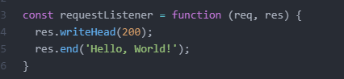

These lines of code will make it so that when the server starts up it will access the data belonging to this website in particular.



These lines of code will make it so that the server will launch on a specific port and this page can only be accessed on said port

* 1. The server.listen(8080) can be interchangeable with any other number as long as it has server.listen(). You can not have anymore than 5 numbers within the parentheses

1. Next step is to start the server
   1. Open command prompt and navigate to where the file is saved. EX “C:\Users\name\Documents”
   2. Once you are in the folder where the file is saved type in “node server.js”
      1. This server.js is whatever you named the file
   3. Open your browser and in the address bar type “localhost:8080” this will then navigate to a white webpage with the words “Hello, World!” on it or whatever you have in the ‘res.end();’ parentheses.